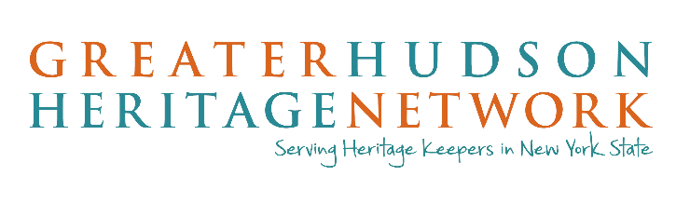
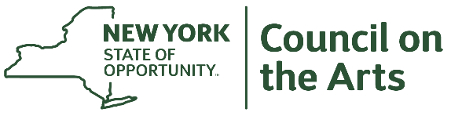

The NYSCA/GHHN Creativity Incubator Grant Program will provide New York State museums with financial support (up to $5,000 each) to experiment with and/or implement ideas inspired by the spirit of the Creativity Incubator workshops, held from 2017-2019.

For the past three years the “Creativity Incubator,” a partnership between the Greater Hudson Heritage Network (GHHN) and the New York State Council on the Arts (NYSCA) Museum Program, has offered “creativity labs” in seven different museums across New York State. With the goal of encouraging museums to think more imaginatively about the interpretation of their collections and to explore new ways to engage with contemporary audiences, these labs were an opportunity to brainstorm ideas using an actual collection or space. Based on feedback from those participants, GHHN and NYSCA are now offering funding to help empower museums to make change. This could involve testing out ideas, partnering with other Creativity Incubator participants to explore new approaches, or for those who are ready – to implement.

We anticipate funding at least seven grants at a maximum of $5,000 each in multiple regions of New York State. No match is required.

Applicant Eligibility
- Applicant must be a museum or historic site located in New York State and open to the public on a regular basis.
- Sites owned by state agencies and religious institutions may not apply
- Priority will be given to participants from Creativity Incubator sessions. If a participant has changed jobs since then, the current and former museum are considered priorities. (Priority means that at least four of the seven awards will go to institutions that have participated in one of the seven Creativity Incubators.)
- The proposal must be creative and approach collections/interpretation in a new way. It may be directly or indirectly inspired from a Creativity Incubator or from other ideas.
- The project may only occur between March 1, 2020 – December 31, 2020.

Application Deadlines
Program deadline is 11:59 pm on February 15, 2020 (Portal opens January 1, 2020)

Please note that our application process is paperless. All materials must be submitted online. The submission portal is located at www.greaterhudson.org. Once the portal is open, and you have signed in to your Submittable account, you may save a draft of your application online and come back to as often as you wish. However, once your application has been submitted, you cannot make any edits or changes. Incomplete applications will be rejected. Prior to the portal’s opening date, a PDF preview of the questions will be available online for applicants’ reference. Please contact GHHN with any questions you might have about the application process.

Panel Review Process
Applications will be reviewed for eligibility. All eligible requests will be considered for funding. A Panel comprised of GHHN and NYSCA staff, and a “Museum Maverick” from the Creativity Incubator sessions will review the submissions. Applicants will be rated on their creative approaches and responses to application questions. Those with the highest ratings will be awarded grants.

Schedule of Completion
Award recipients will be announced approximately two weeks after the application deadline date. Funded work must be completed by December 31, 2020. If you do not expend the funds by this date, you will be obligated to return them. Should there be an unanticipated change in your projected timeline of activities, you MUST contact GHHN before proceeding.

Application Process
Our application process is paperless. The submission portal is located at www.greaterhudson.org. It will open on January 1, 2020 and will remain open until 11:59 pm on February 15. All information must be submitted by that deadline. You may fill out your application at any point during that date range.
To begin your application, you must create a FREE Submittable account. You will fill out a form with your name, email address and a password. If you already have a Submittable account (from other grant programs), you should use that username and password to log in. You will need to be logged in to complete and submit your application. Once you have logged in, you will be able to access the application.
The application will be filled out in fields in the portal and we highly recommend that you compose your answers offline and copy/paste them into the online form so that you have your work backed up if there is a technical issue. Please note, questions with fillable fields will not accept formatting such as bulleted lists or boldface or italics.
Below, you will see a detailed description of each part of the application. Your application process will move along more smoothly if you have all the required information and files ready before you begin

How to Apply: Written Narrative or Video
There are two ways to apply for the Creativity Incubator grant – through a written narrative or a maximum 4-minute video. You may select either method – there is no benefit to selecting one over the other. Regardless of the method you choose, you will need to answer all the application questions. Both methods also require you to fill out the organization questionnaire and accept that the amount awarded is $5000.
The application consists of:

Organization Questionnaire - Filled out in Portal
The Organizational Questionnaire is primarily made up of the questions about your organization– address, contact email, contact phone number, EIN number, etc.

2. Project Description – Filled out in Portal or uploaded as a video
The Project Description is a space for you to explain what you plan to do with this grant award. You will need to answer the following questions – regardless of whether you provide your answers in writing or video:
1. What problem are you trying to solve? (Hint: this should be able to be explained in one or two sentences).
2. What do you plan to do?
3. What questions do you want to explore?
4. How is your approach creative and different? Has anyone tried it before?
5. Do you face any challenges in being creative?
6. Who will work on this and what is their background?

Please note, the form will not accept formatting such as bulleted lists or boldface or italics. The field also has a word count, however, more space has been provided for the question than is required.

Remember, if you are submitting a video application, your 4-minute video must answer all the questions above however you choose to visualize it

3. Project Budget – Filled out in Portal
The grant award is $5000, and no match is required. Any unspent funds must be returned to Greater Hudson Heritage Network, payable to Greater Hudson Heritage Network. Any expense above $5000 is the responsibility of the applicant. You will need to indicate your agreement of this in the portal. Staff time is an allowable expense for this grant. This grant may not be used to pay for food or hospitality items.

Important Note

Applicants who are awarded this grant will be required to accept the grant award by providing a signed letter from both the organization’s Executive Director and Board President confirming their approval and willingness for the organization to participate in this grant program.

Final Evaluation
NYSCA/GHHN Creativity Incubator Grant Awardees have a requirement to prepare a written Final Evaluation after completing the project. You will need to be logged in to complete and submit your Final Evaluation. Once you have logged in, you will be able to access the questions.
The deadline for Final Evaluations for the Creativity Incubator Grant is 30 days after completion of your project. Failure to submit the required evaluation may impact future funding eligibility. The portal for the Final Evaluation will be available as of June 1, 2020 and can be accessed through: https://greaterhudson.submittable.com/submit
You must notify GHHN if you do not anticipate spending all your awarded funds. Any unspent funds must be received back to GHHN at the time of Final Evaluation submission, made payable to Greater Hudson Heritage Network.
Your Final Evaluation MUST consist of:

- A narrative addressing the following questions:
  - What worked?
  - What didn’t?
  - What did you learn?
  - Where is this project taking your organization?
  - How did you spend the funds or are you returning any money?

OPTIONAL: If you would like, you may attach press releases, announcements, publications, and exhibit or program materials referring to the grant program. If you post on Facebook, Instagram or Twitter about the awarded funds, please make sure to tag Greater Hudson Heritage Network (@theGHHN) and the New York State Council on the Arts (#nyscasupported).

Questions?
Priscilla Brendler, GHHN Executive Director
director@greaterhudson.org or 914.592.6726

Kristin Herron, Arts Program Director, Architecture + Design │Museums
Kristin.herron@arts.ny.gov or 212.459.8825

