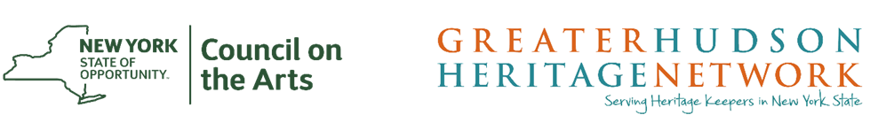

The NYSCA/GHHN Collection Needs Assessment Program (CNAP) is a new NYSCA/GHHN Grant partnership program which will provide two opportunities for museums across New York State. These are the guidelines for the Final Reports required for the Supplies Program.

Final Reports
NYSCA/GHHN Collection Needs Assessment Program Grant Awardees have a requirement to prepare a final report. Please note, our final report submission process is also paperless. To submit your Final Report, you must use your previously created Submittable account. You will need to be logged in to complete and submit your Final Report. Once you have logged in, you will be able to access the Final Report questions.

If your supply request was granted in the May 2017 round, your Final Report is due by November 1, 2017. If your request was granted in the October 2017 round, your Final Report is due by April 1, 2018.

Please Note: You must notify GHHN if you do not anticipate spending all your awarded funds. Any unspent funds must be received back to GHHN at the time of Final Report submission, made payable to Greater Hudson Heritage Network. Unspent funds will be re-granted in subsequent grant rounds.

Your final report MUST consist of:
- A narrative (maximum one page) addressing the following:
  - A narrative accounting of how grant funds were spent, i.e. what was purchased with the funds and their purpose.

- Attach an accounting of grant expenses, indicating total awarded and total project expenses.

OPTIONAL: If you would like, you may attach press releases, announcements, publications, and exhibit or program materials referring to the grant program. If you post on Facebook or Twitter about the awarded funds, please make sure to tag Greater Hudson Heritage Network (on Twitter:@theGHHN) in the posts so we may see the post.

Questions?
Please contact Priscilla Brendler, GHHN Executive Director director@greaterhudson.org
914.592.6726
The NYSCA/GHHN Collection Needs Assessment Program is made possible with funds from the New York State Council on the Arts, with the support of Governor Andrew M. Cuomo and the New York State Legislature. ​

