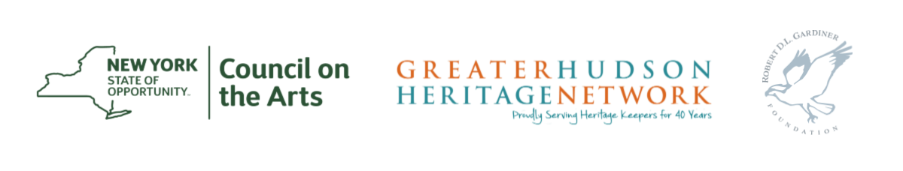

The NYSCA/GHHN Conservation Treatment Grant Program is a partnership of the New York State Council on the Arts (NYSCA) and Greater Hudson Heritage Network (GHHN) that provides support for treatment procedures to aid in stabilizing and preserving objects held in collections of museums, historical, and cultural organizations in New York State. The Robert David Lion Gardiner Foundation has provided additional dedicated support for conservation treatment projects in Nassau and Suffolk Counties.

This is a checklist to give to your conservator of choice to ensure that your application has all the necessary parts to be discussed by the grant panel.

To be supplied by the conservator:
- Condition Report
The condition report should note the object’s material(s), construction, size, historical alterations, previous repairs, and the extent and severity of destruction. Prior to writing a condition report, the conservator MUST examine the object in person. Remote consultation is not acceptable. Conservators should conduct testing during condition assessment or indicate why they could not.

- Treatment Proposal
Treatment proposal should be prepared within the last 12 months prior to application, and include the following information:
- Conditions that will be corrected by treatment
- History of object and its care if relevant
- Proposed treatment
- Goal of treatment
- Proposed treatment materials and techniques – please include a materials list when using specialized conservation materials that may be specific to object types

The proposal should address the condition problems mentioned in the Condition Report. When there are multiple possibilities for treatment, your choice should be discussed. Treatment should be responsive to the condition problems, to the projected use, and to the environment of the institution. Please provide actual costs of treatment – ranges will not be accepted.

You may send the Condition Report, Treatment Proposal and Estimate as a singular PDF file, or as three separate files. All treatment proposals must follow requirements in AIC Guidelines for Practice and Commentaries.

- Conservator’s Resume
Conservator’s Resume should include the following elements:
- Name of conservator, name of business, contact information
- Short description of practice
- Employment history
- Publications and selected presentations
- Formal education and internships (not meetings attended)
- Organization memberships
- Awards
- No client list or references
- A bio is not a sufficient replacement for a resume and will not be accepted

Resumes MUST be from the conservator who supplies the treatment proposal and cost estimate. Please make sure to include resumes of all other conservation professionals who will participate in the proposed treatment. Omission of resumes may deem the application ineligible for funding. Eligible conservators may be in private practice or associated with a regional conservation lab.

Note: Conservation professionals cannot be contracted for grant work in their capacity as employees of state or federal agencies.

- Letter of Commitment
All conservators must submit a letter of commitment. The letter must be:
- On letterhead
- Dated within the last twelve months prior to application deadline
- Addressed to the applicant
- Include commitment to complete treatment before end of grant period
- Be signed by the conservator
- Acknowledge that all documents and work provided will be in accordance with the
AIC Code of Ethics, Guidelines for Practice, and Commentaries

- Visual Support Material
Good quality photographic images enhance the panel’s ability to determine the condition of the object. The conservator is responsible for providing this photographic documentation to the applicant.

Please submit color photographs which must include:
- At least one overall and one detail image of each object proposed for treatment - inclusion of more than one image per object is required
- Images showing the object in situ and where it will be exhibited post-conservation
- Images should clearly show the condition problems of the object(s) and any areas of damage that are referenced in the narrative or in the conservator’s condition report
- For paintings, inclusion of images of the verso is highly encouraged

